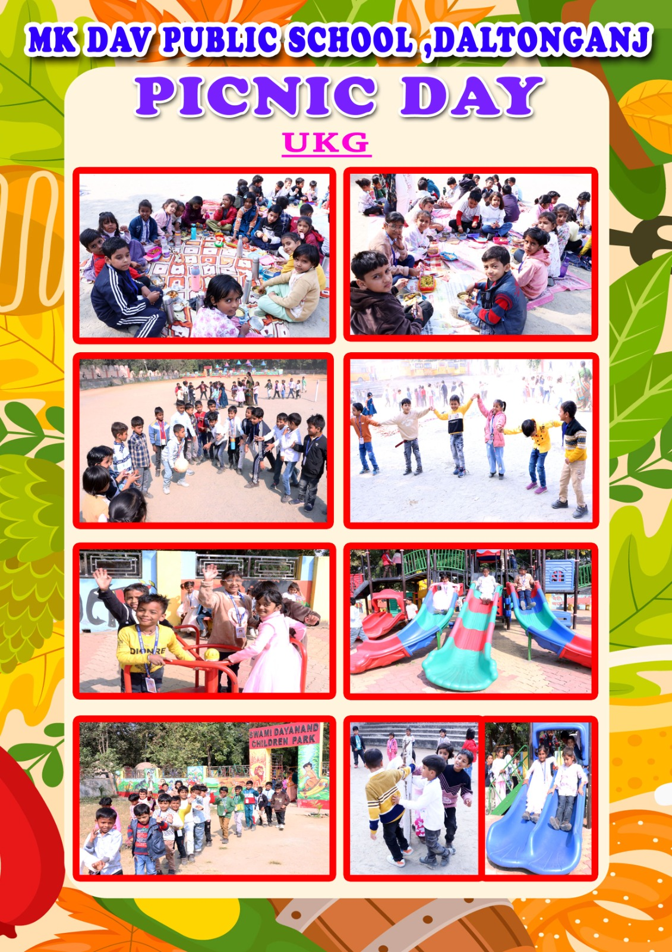

Fun & Frolic Unfold Again: A Joyous Picnic for Class UKG and III at M.K DAV Public, School Daltonganj

Like the previous day, the school once again echoed with excitement as a vibrant picnic was organised today for the students of Class UKG and III . The campus transformed into a lively hub of cheerful chatter, playful footsteps and wide-eyed wonder as children arrived brimming with enthusiasm. Carrying hampers filled with delightful home-cooked treats, the students spent the day enjoying thrilling rides, engaging outdoor activities and a variety of well-planned games that sparked both laughter and friendly teamwork. The air soon filled with music and merriment as the children danced joyfully to upbeat songs creating moments that beautifully captured the spirit of carefree childhood. Their radiant smiles and unrestrained giggles turned the day into a tapestry of fun, frolic and unforgettable memories.

Appreciating the smooth organisation of the event, the Honourable Principal, Mrs. INDRANI CHATTERJEE expressed her delight on seeing the young learners immersing themselves wholeheartedly in such enriching experiences. She emphasised that such well-structured recreational activities not only refresh the mind but also foster cooperation, courage and a sense of community among children. She further added that days filled with exploration and joy strengthen their emotional well-being and contribute meaningfully to enrich their journey of comprehensive growth and learning.

